- How to Process Digital Signature Certificates (DSC) in ProDigiSign.
- Please visit to ra.prodigisign.com for login.
- Enter login id and Password and click on Log In.

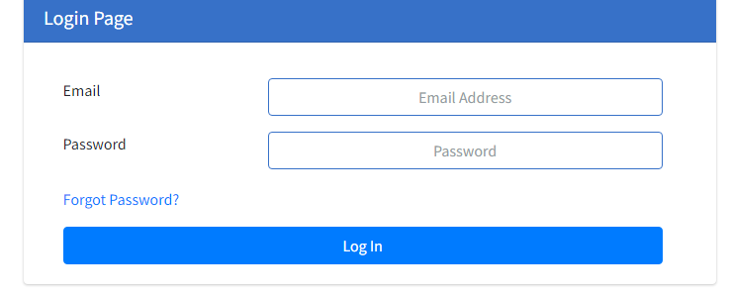
- After login homepage is open.
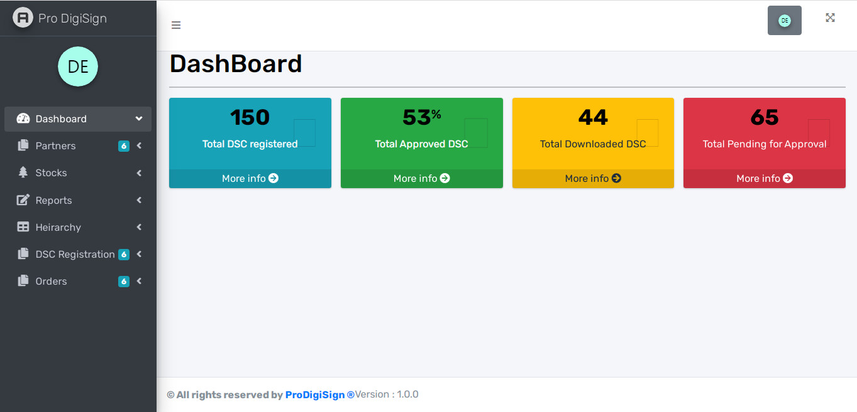

- For DSC processing Click on DSC registration tab which is present on left side under dashboard.
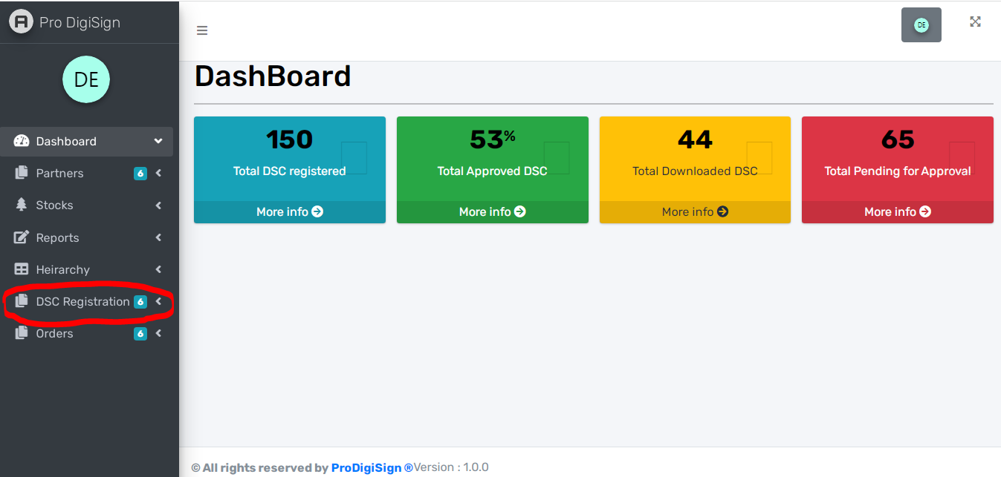

- Select type of DSC registration you want to create.
- Pan DSC, Org DSC or Aadhar DSC.

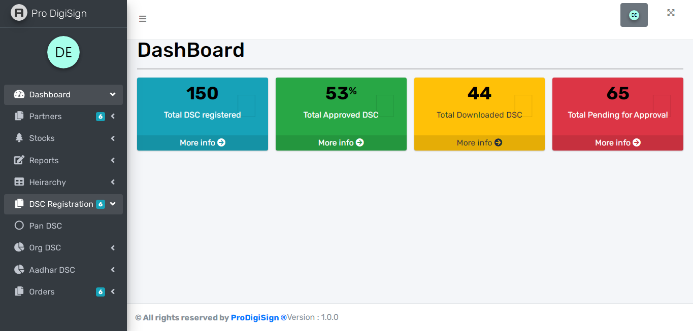

- For Aadhar DSC follows below procedure.
- To upload file (xml or zip) click on “click here” link as shown in below.
- After that do login on Aadhar site and download xml or zip file.
- Upload the same file and 4 digit pass code (e.g.1234) and enter on “Proceed”.
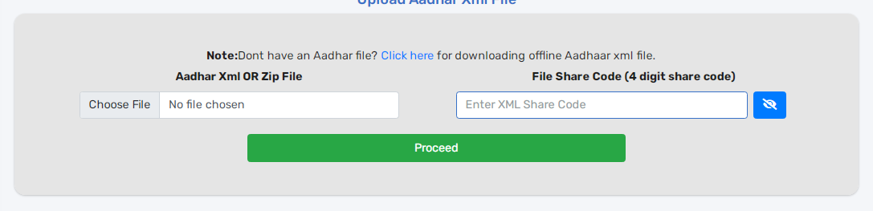
- First select certificate class: Class 3
- Certificate type: Signing, Encryption or Signing & Encryption
- Certificate validity: 1 year, 2 years or 3 years
- Enter required applicant information as shown in below form
- After entering Email ID and Mobile No “Send OTP” button display
- Verify these email and mobile OTP by clicking Verify button
- Ekyc id is generated automatically when entering Pan Number
- Enter Ekyc pin and download key (Limit is 5 digit)
- Click “Proceed” button.
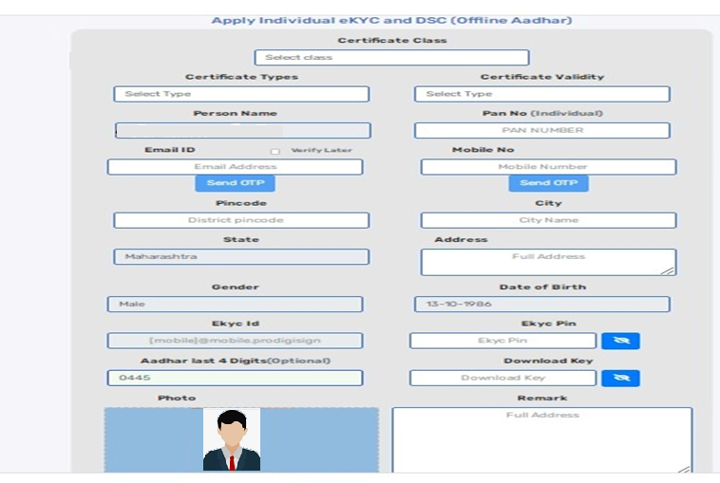
- After that one application form is opened. Please read and check the information of applicant filled carefully and click on check box and submit the application.

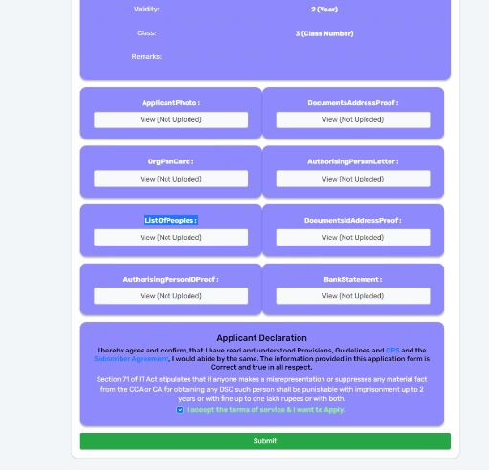

- After submitting application PID (Product Id) is generated and video link popup is displayed. Copy this video link and share with applicant.(video Link automatically shared on applicant email id)
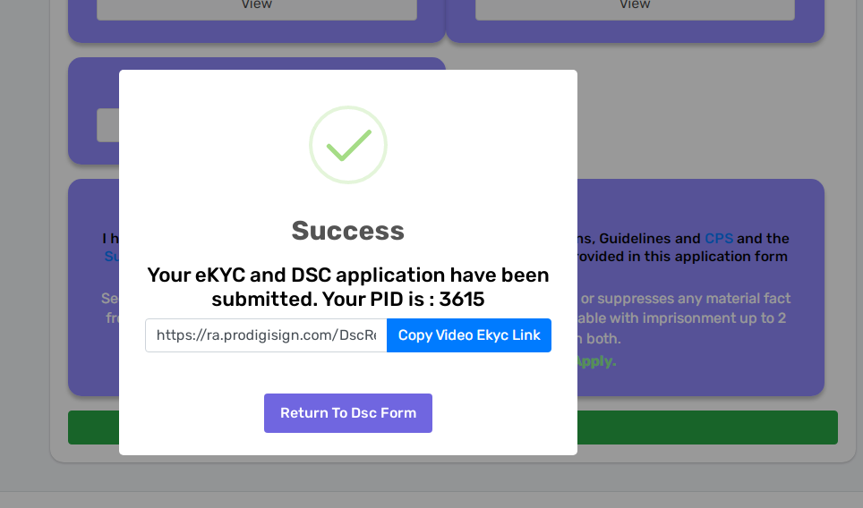

- When applicant opens the video link ask him to click on start camera then start recording and read the given script in video and submit video after 25 seconds. (For Aadhar base DSC no original documents need to be shown in the video).

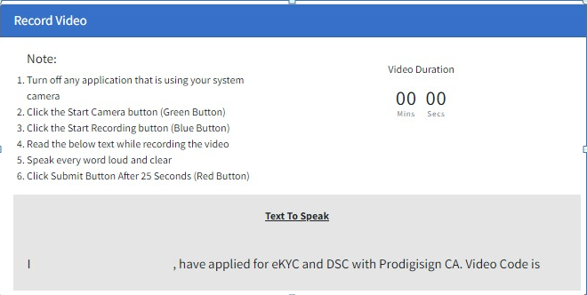
- After that go to Orders and Order listing.
- Click on PID for knowing status of DSC.
- Click on Edit button if you want to change any information of applicant.

- Please note that we can edit the applicant information before the PID is approved.
- Once DSC status is approved DSC is ready to download.

